

Lubricity Durability Verification,
Silq Surface Treatment

Test Protocol

Purpose

The purpose of this protocol is to summarize the test method used to demonstrate the lubricity of flat silicone sheets treated with the Silq Surface Treatment relative to non-treated silicon sheets and the durability of the Silq Surface Treatment.

Scope

This comparative study applies to Silq’s Surface Treatment process.

Testing was conducted to determine the drag force of a flat plastic sheet sliding over silicone substrate in accordance with ASTM D1894-14.

Documents

Reference Documents

ASTM D1894-14, Standard Test Method for Static and Kinetic Coefficients of Friction of Plastic Film and Sheeting

Definitions

Abbreviations / Acronyms

ASTM: American Society for Testing and Materials

Background

The coefficient of friction is determined by dividing the drag force required to pull one material across another. In this measurement, the two materials are analogous samples of silicone: Silq surface treated silicone or bare silicone. Bare silicone is known to have an especially high coefficient of friction due to its inherent tackiness. This report is meant to demonstrate the drastically reduced coefficient of friction of silicone as a result of applying the Silq Surface Treatment. The results of this study also demonstrate the durability of the Silq Surface Treatment by showing both the static and kinetic coefficient of frictions remain constant after 100 cycles of abrasion. For this study, a 216 gram sled (4.5 in²) was pulled across the full length of a 10” by 5” substrate at a rate of 5.9 in/min.

The static coefficient of friction was calculated from the following equation:

µ_{s} = A_{s}/B

where, µ_{s} is the static coefficient of friction,

A_{s} is the average static drag force, and

B is the sled weight.

The kinetic coefficient of friction was calculated from the following equation:

µ_{k} = A_{k}/B

where, µ_{k} is the kinetic coefficient of friction,

A_{k} is the average kinetic drag force, and

B is the sled weight.

Both the drag forces and sled weight are measured in grams.

Test Method

The test method was adopted directly from ASTM D1894-14.

The following equipment were required for the execution of this test:

MARK-10 ESM 3000 Motorized Test Stand (calibrated by Anmar Metrology on 4-14-21)

MARK-10 Force Gauge (Model M5-05)

Pure silicone was used as the substrate for this study. Test samples (Silq surface treated and bare) were cut to 10” by 5” dimensions. The 10” by 5” sample was placed on the drag plane with the 10” side placed along the machine direction.

A second piece of analogous silicone was cut into a 4.5” square and taped to the bottom of the weighted sled. The total weight of the sled and silicone was 216 grams.

The drag force (in grams) required to pull the 216 gram sled at a rate of 5.9 in/min was measured for each substrate and recorded.

To obtain the static coefficient of friction, the highest drag force value measured by the force gauge was used.

To obtain the kinetic coefficient of friction, the average drag force value while the sled was in motion was used.

Each Silq surface treated sample specimen was initially tested 5 times. For comparison, one bare silicone sample specimen was also initially tested 5 times.

For demonstration of the durability of the Silq Surface Treatment, the drag force of one sample specimen was measured for 100 cycles.

equivalent static and kinetic drag forces over 100 cycles of testing a weighted sled across the treated silicone substrate.

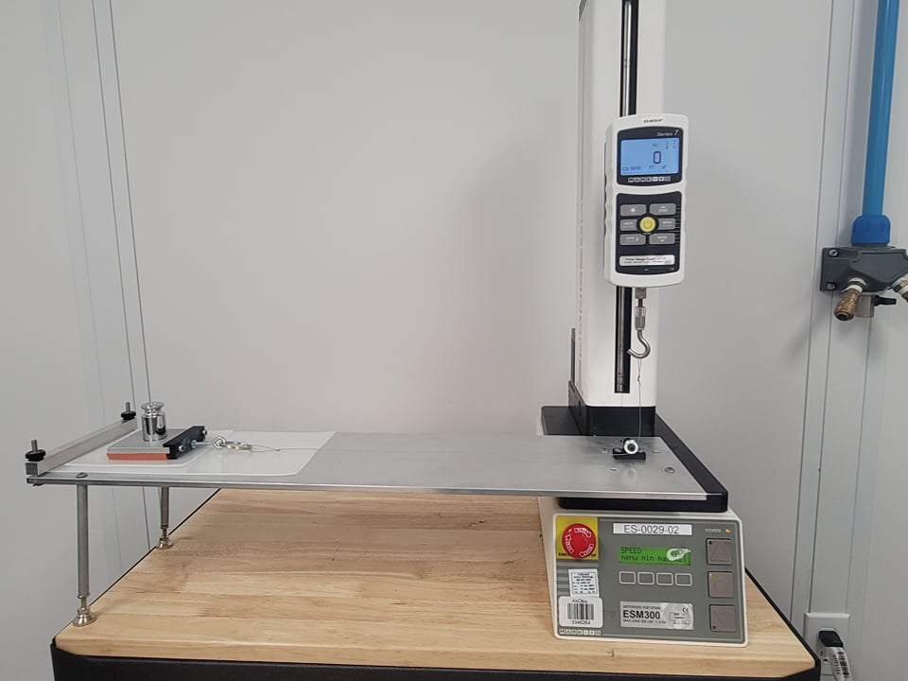
MARK-10 ESM 3000 Motorized Test Stand
MARK-10 Force Gauge
10” x 5” Silicone Substrate
4.5” x 4.5” Silicone Substrate
Weighted Sled
Machine Direction

